Dharshini M

Date:5/1/2024

Mail: [dharshini.m003@gmail.com](mailto:dharshini.m003@gmail.com)

Topic: Azure Data Factory

Pipeline creation

Create a blob storage account

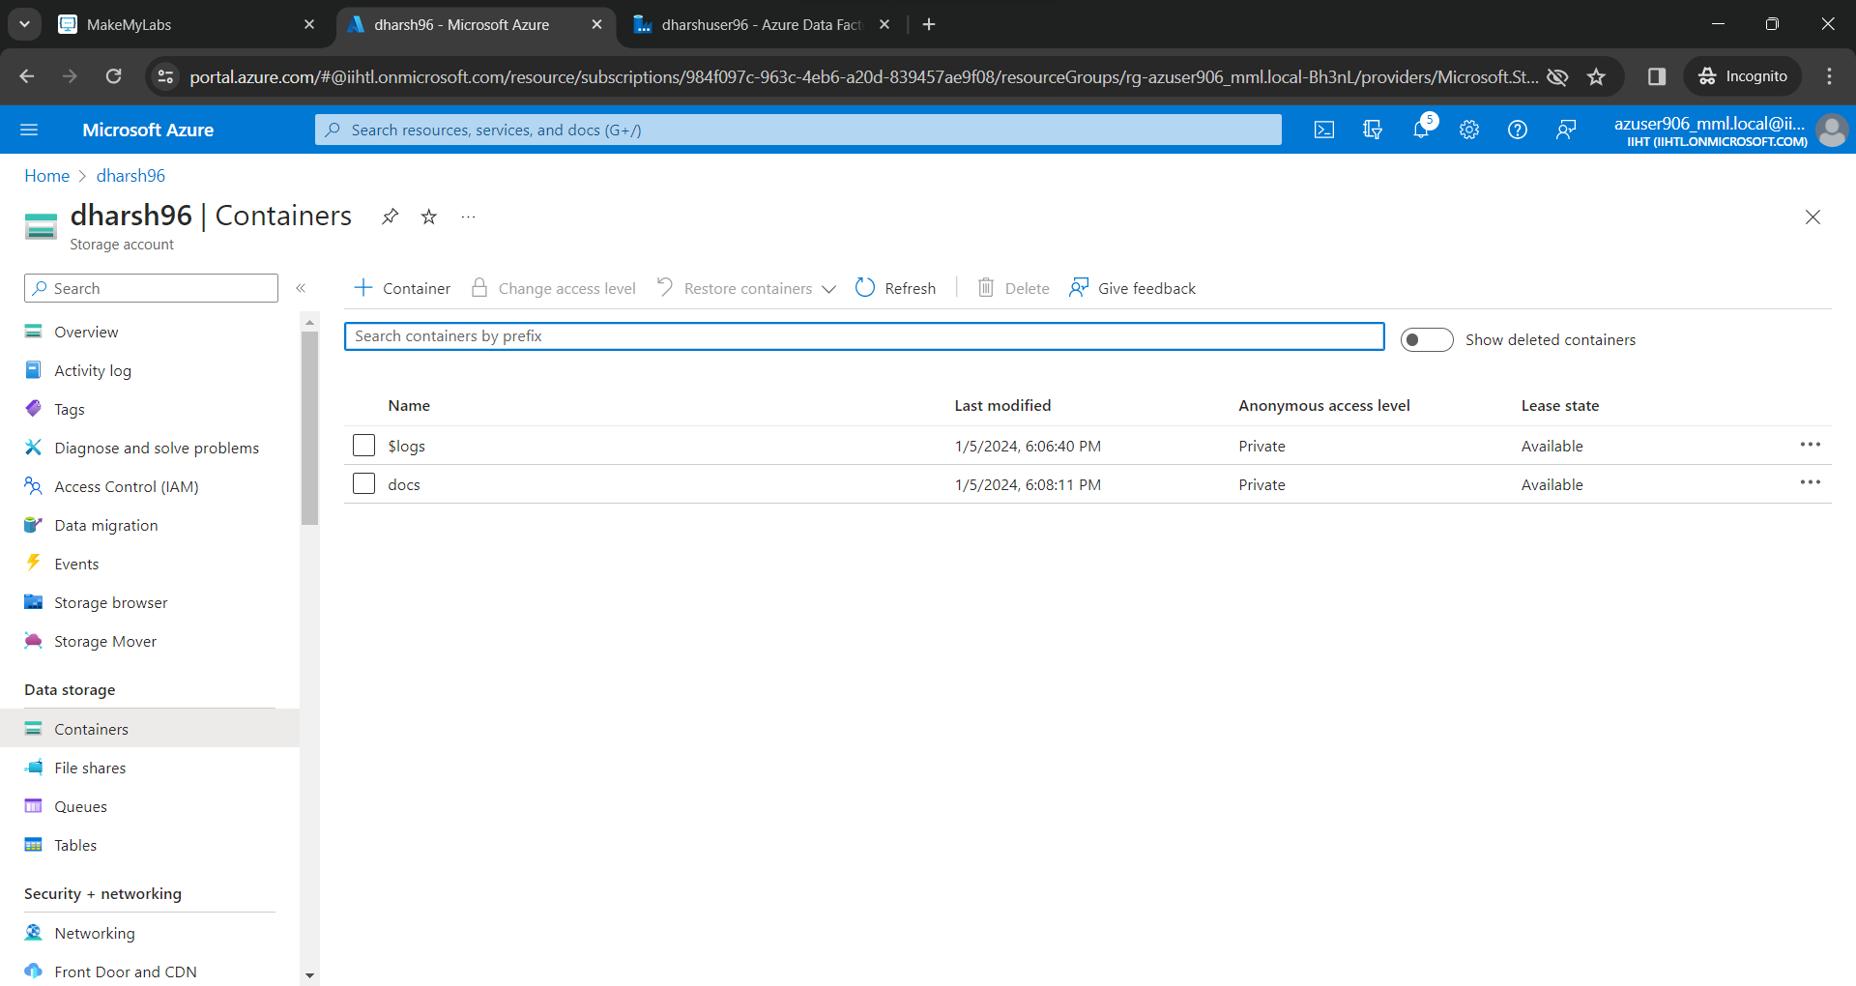

Create a gen2 storage account

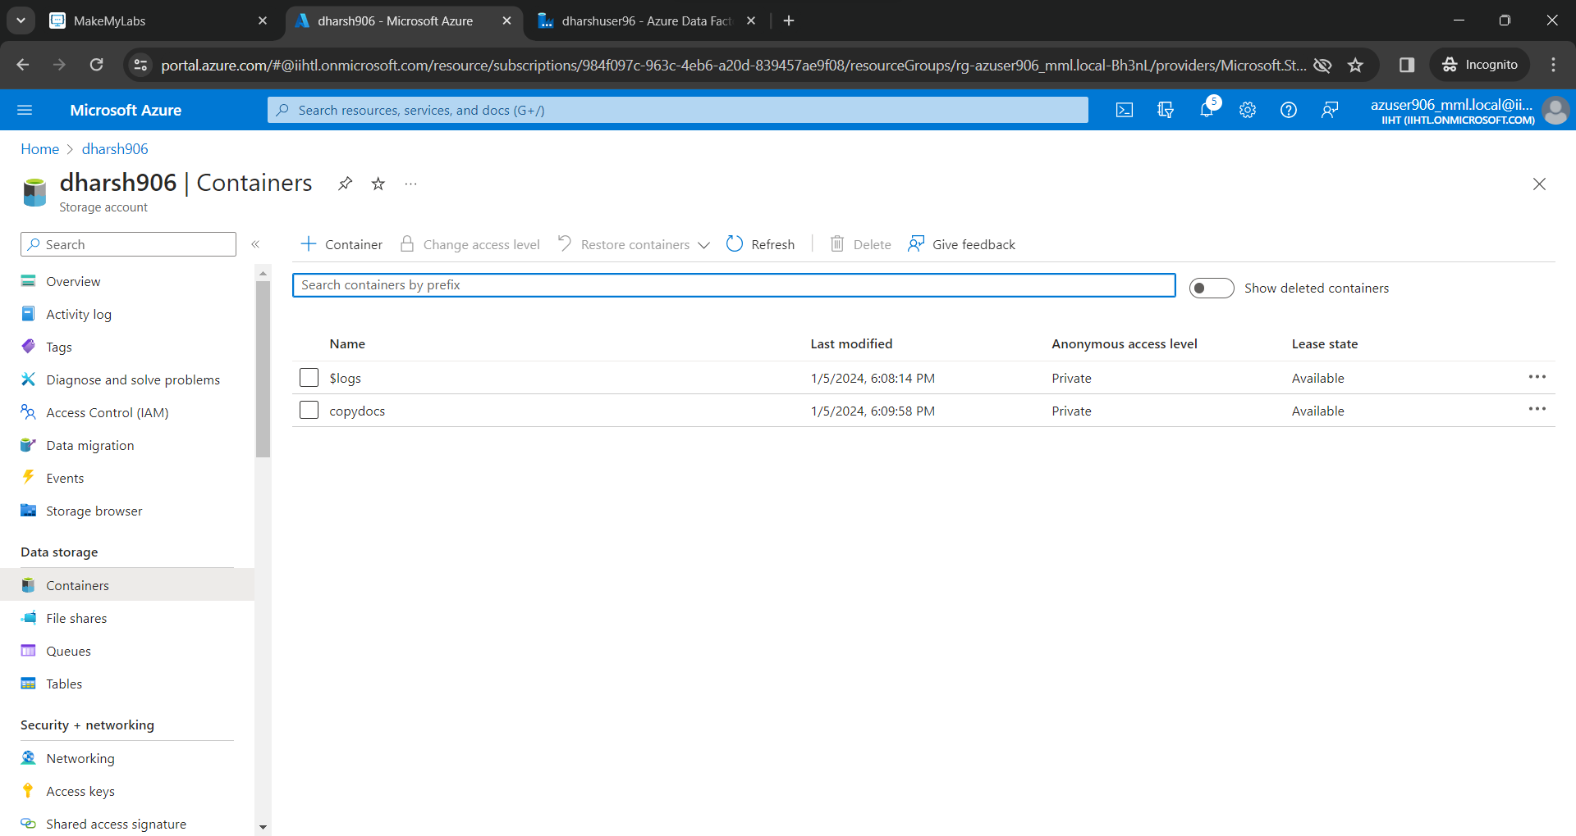

Create a pipeline and add source

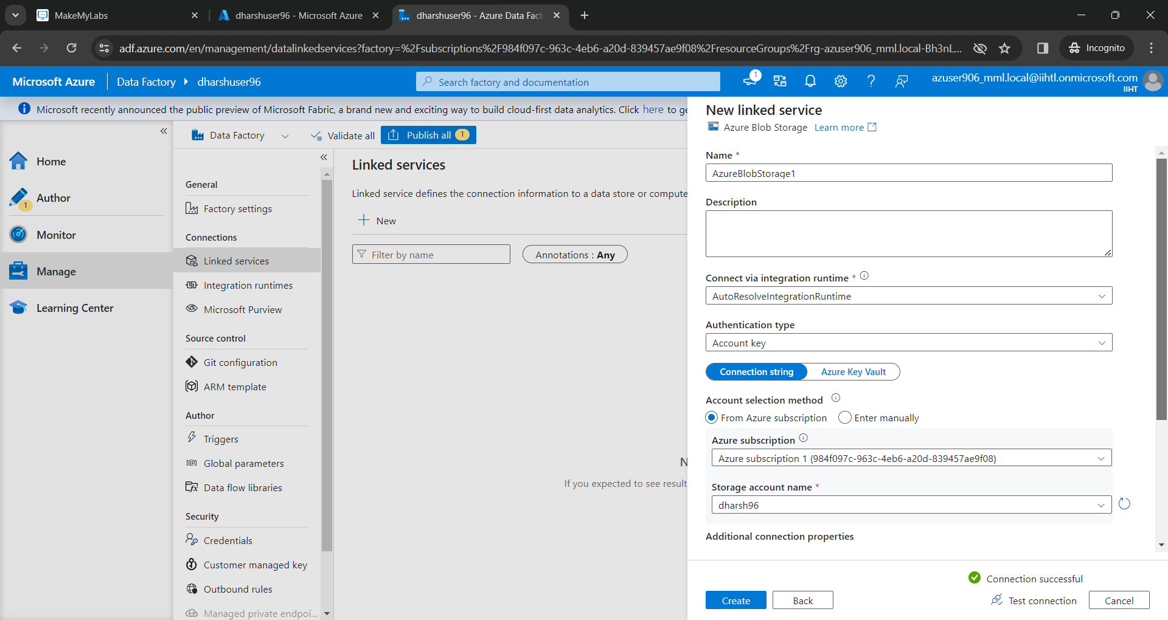

Add the destination

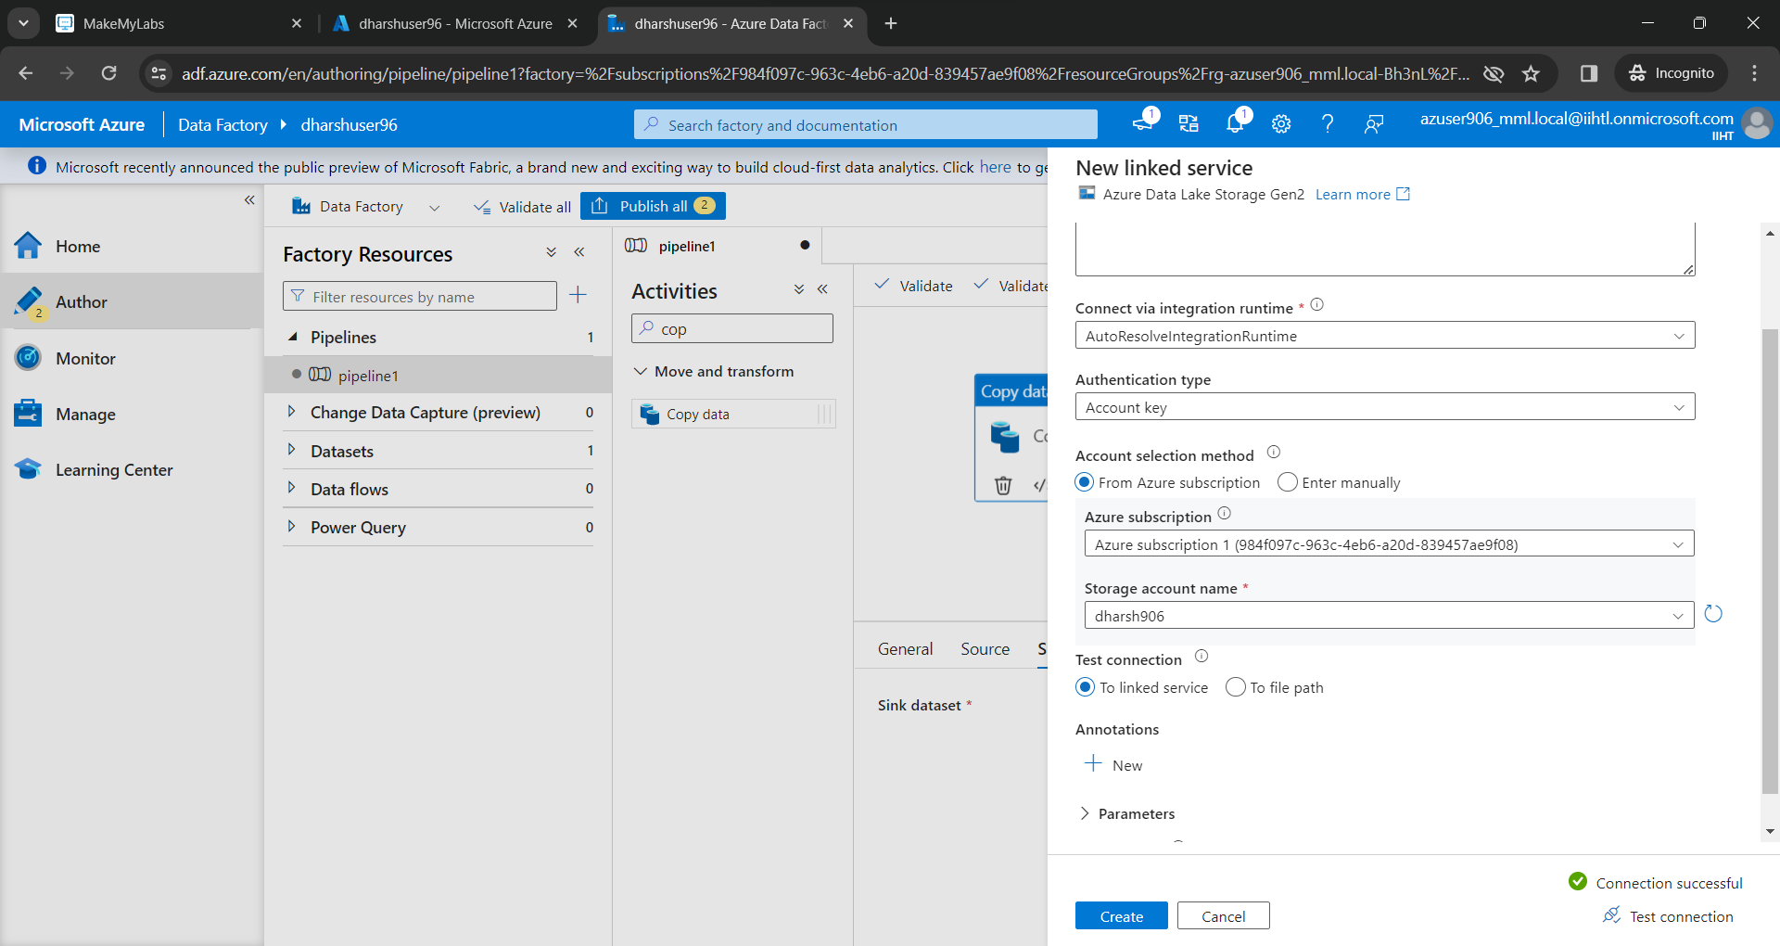

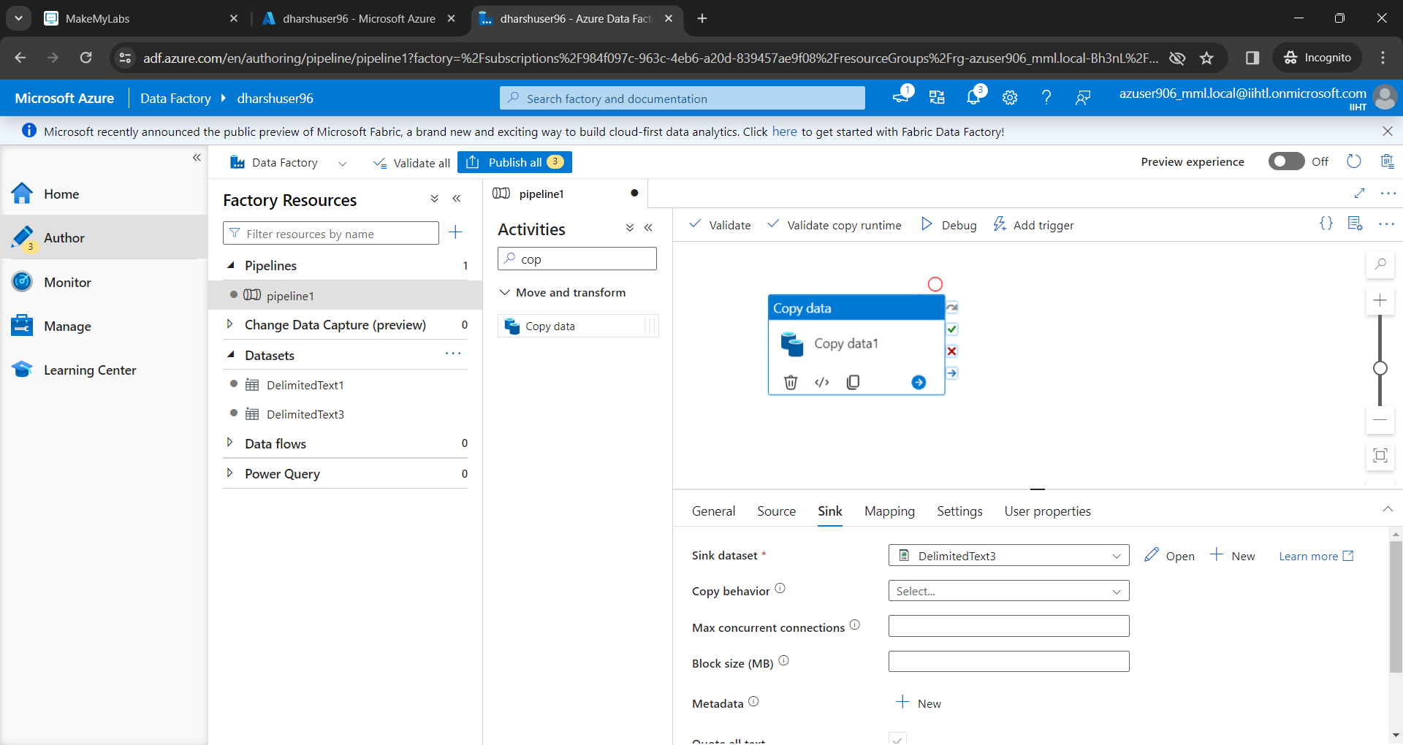

We are transferring a file from blob storage account to gen2 storage account

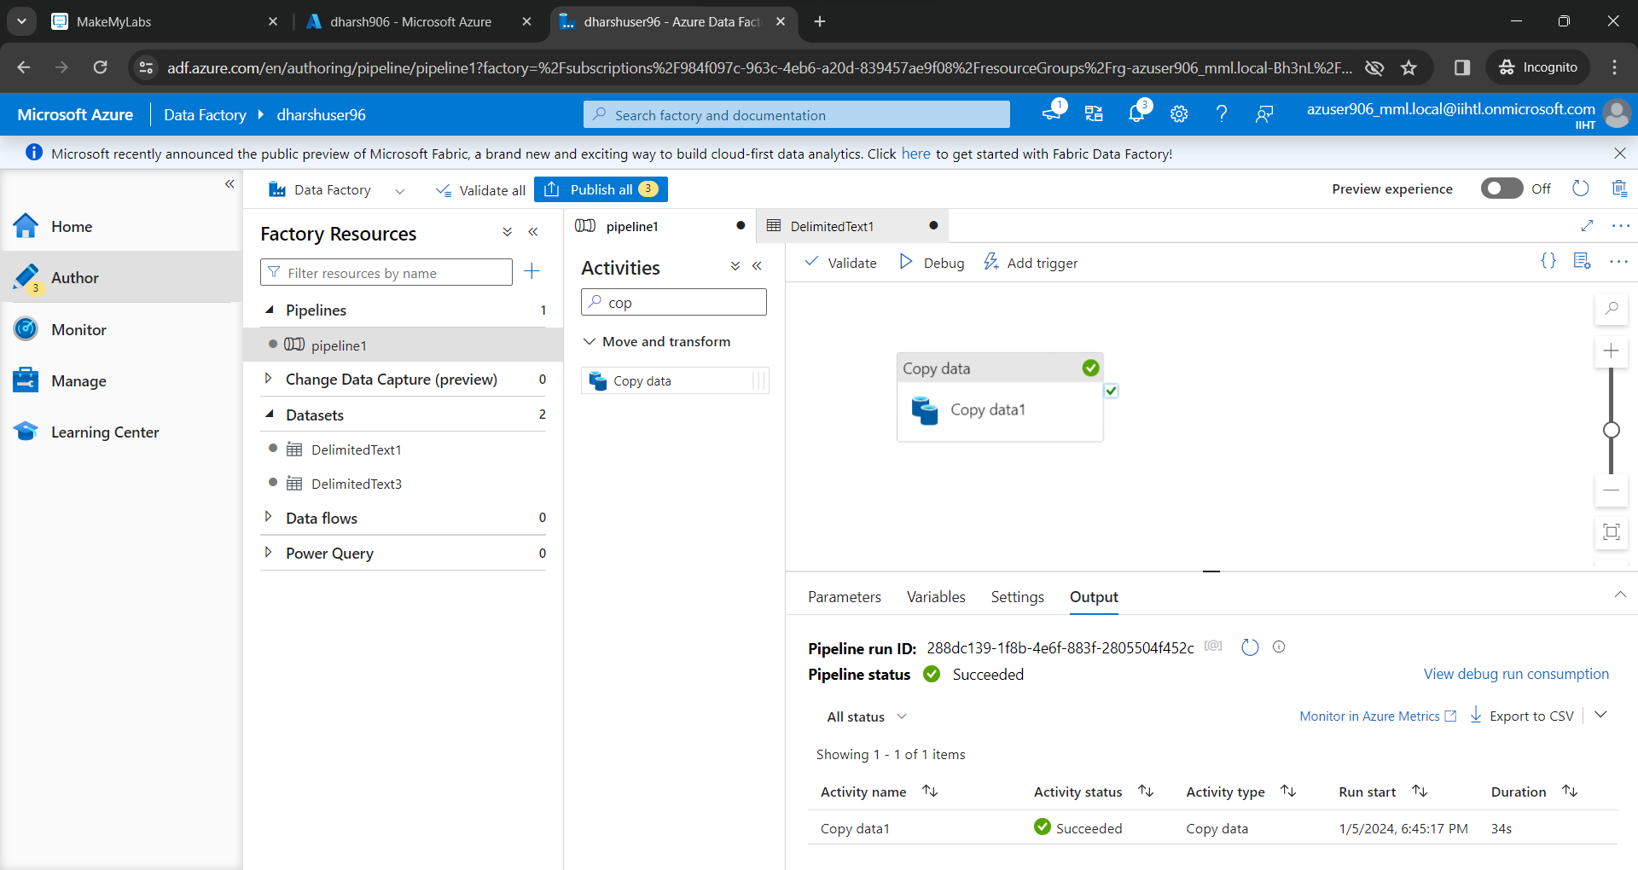

The file has successfully transferred

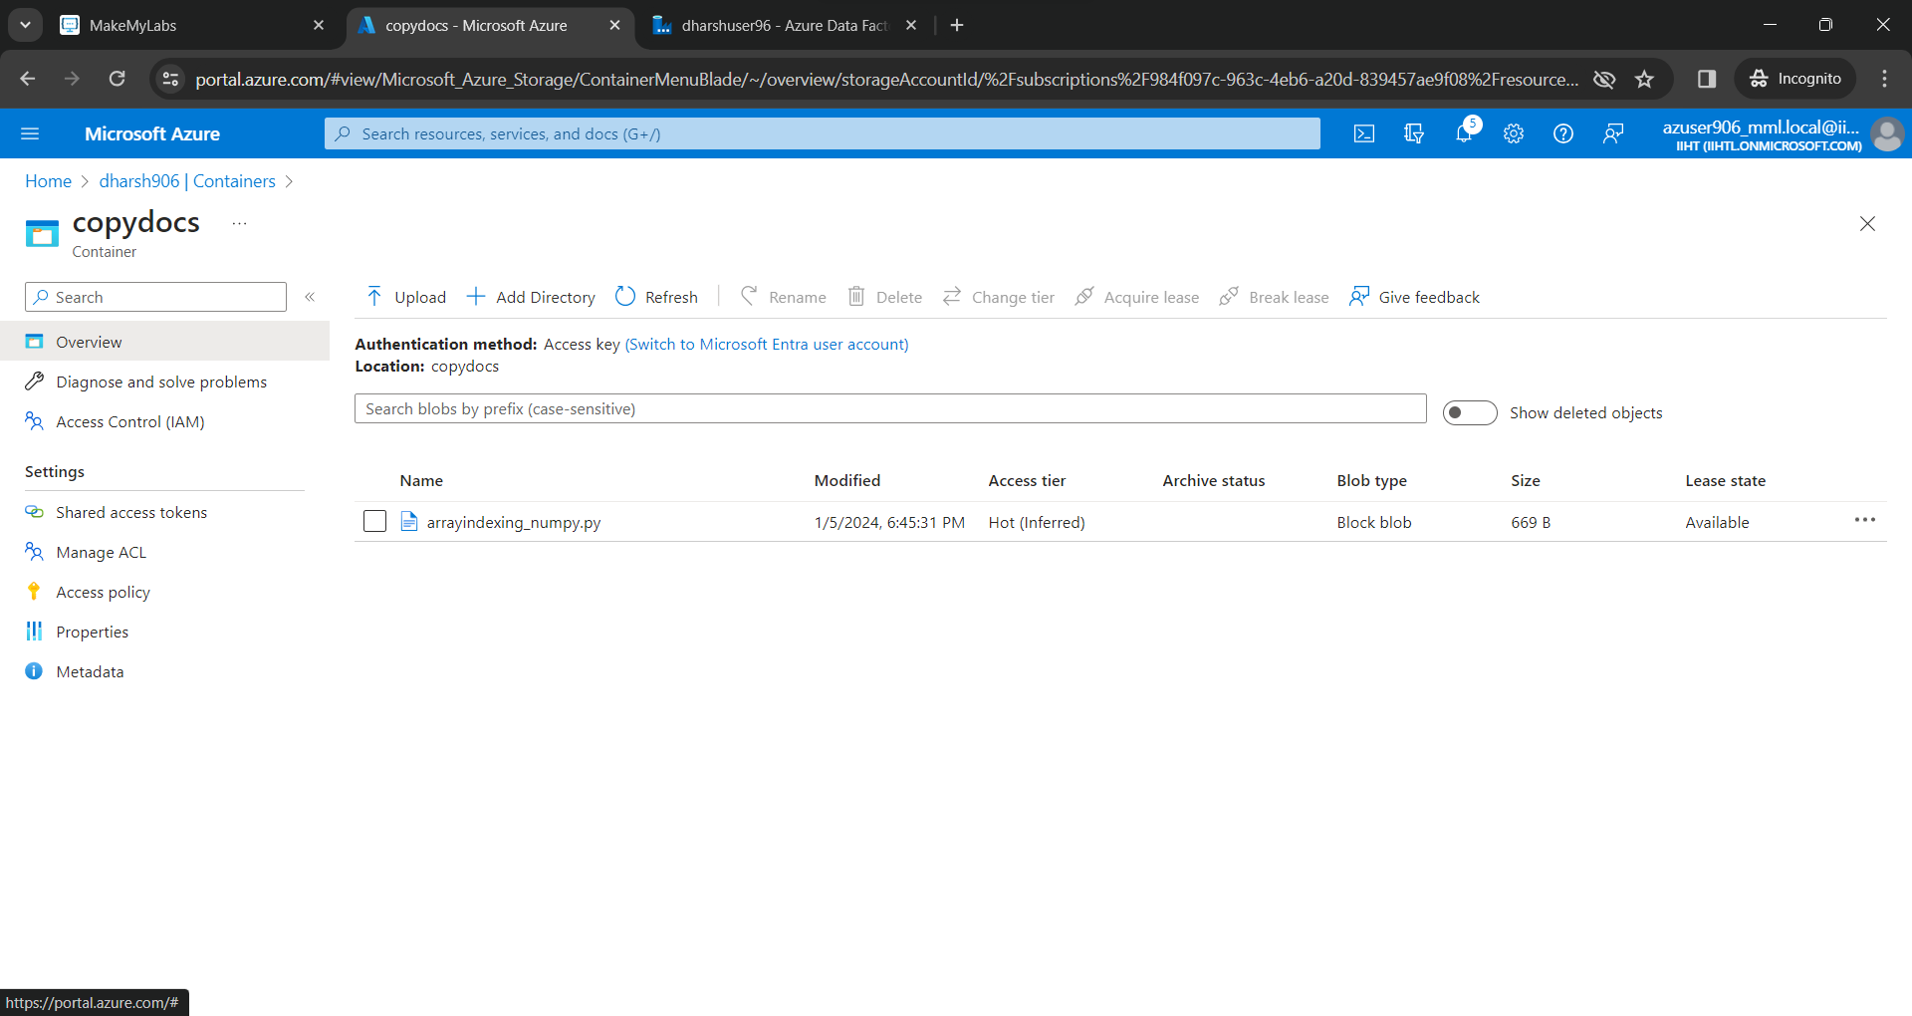

Delta live tables is solely responsible for performing data transformation and managing the task orchestration, cluster management, monitoring, data quality, and error handling.

Benefits of working with Delta Live tables are

* Accelerates the ETL Process
* Automatically manage your infrastructure
* Ensure high data quality
* Unify batch and streaming

Medallion Lakehouse Architecture:

* Bronze Layer
* Silver Layer
* Gold Layer